Sprouts
A game for two players
Start with three dots on a piece of paper. Players take turns to draw a line starting on a dot and ending on the same or a different dot and then putting another dot on this line. A line must not cross another line. A dot cannot be attached to more than three lines. The first player who cannot go is the loser.

position at start possible position after one turn
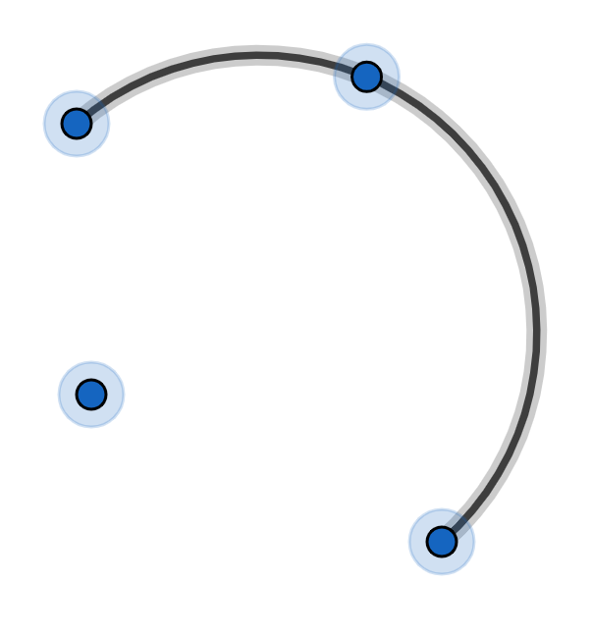
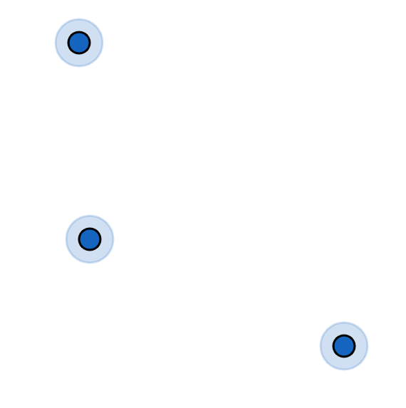

Can you think of a good strategy to play this game? (I can’t)
Note: each dot can attach to three lines and each turn uses up two attachments and creates one new attachment so the game must eventually end.
Note: you can vary the number of dots at the start.
Note: think of the dots as vertices and the lines as edges and then every position is a planar graph.

Brussel sprouts
A game for two players
Start with three crosses on a piece of paper. Players take turns to draw a line starting on an arm of a cross and ending on an arm of the same or a different cross and then putting another cross on this line. A line must not cross another line. The first player who cannot go is the loser.

position at start possible position after one turn

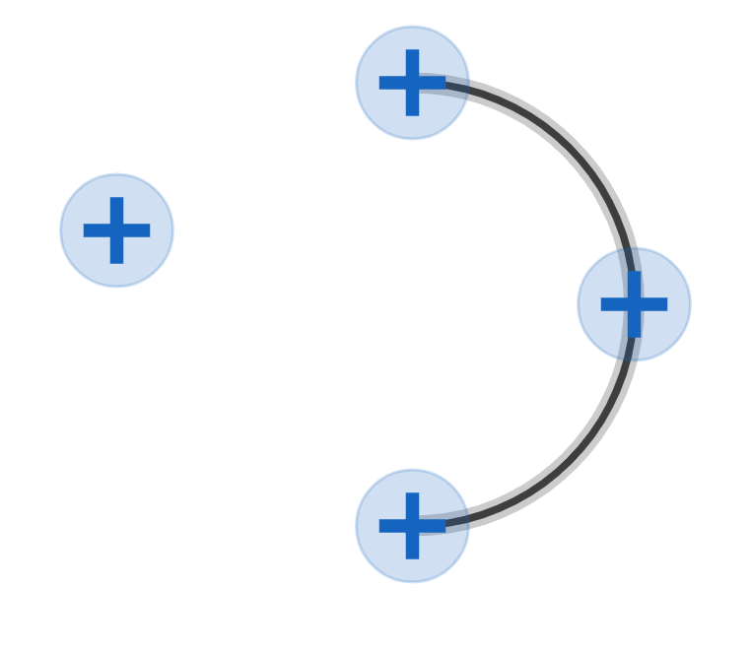
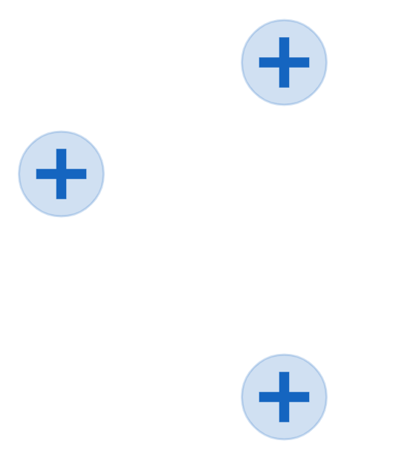

Note: each cross can attach to four lines and each turn uses up two attachments and creates two new attachments so it is not obvious if the game will ever end.
Note: you can vary the number of crosses at the start.
Note: think of the crosses as vertices and the lines as edges and then every position is a planar graph.

Brussel Sprouts is a con. If you start with three crosses then the game will always end after 13 turns. So the first player will always win.
Play a game and look at the final diagram. We start with 3 crosses, that’s 12 attachments. At the end of the game each attachment is in a separate face, so
If the game ends afterturns:
Each turn adds one vertex.
So:

Each turn adds 2 edges.
So:

Euler’s formula says:

So:

So:

In general:
if we start withcrosses, that’sattachments.
If the game ends afterturns:
Then:

Euler’s formula says:

So:

So:

